Date | Non identifying ID
Referral for the assessment | Presenting Problems
Past Medical History | Medications
Allergies | Medication administration
Recent Investigations - print out lab results &/or recent discharge summary from concerto and attach.

Comments

What is concerning the patient the most?

Modified Barthel Score ___ /100 | MSQ Score ____/10  (score 1 for correct answer, 0 for incorrect, no half scores)  Age (allow 1 year error) ___  Time (allow consultation with clock / watch  and error up to 1 hour) ___  Address for recall at end of test - should be  repeated by the patient to ensure it has  been heard correctly “201 Queen St” ___  Year (allow previous year) ___  Name of hospital / home address ___  Recognition of 2 persons (Dr, Nurse etc) ___  Date of birth ( day and month only) ___  Year of first world war ___  Name of present Prime Minister ___  Count backwards from 20 - 1 (no errors, no clues) ___  Recall address
  Items | Unable  To  Perform  task | Attempts  Task but  Not safe | Moderate  Help  reqd | Minimal  Help  reqd | Fully  indep
  Personal  Hygiene | 0 | 1 | 3 | 4 | 5
  Bathing  Self | 0 | 1 | 3 | 4 | 5
  Feeding | 0 | 2 | 5 | 8 | 10
  Toilet | 0 | 2 | 5 | 8 | 10
  Stand  From  Chair | 0 | 2 | 5 | 8 | 10
  Dressing | 0 | 2 | 5 | 8 | 10
  Bowel  Control | 0 | 2 | 5 | 8 | 10
  Bladder  Control | 0 | 2 | 5 | 8 | 10
  Ambulation  (wheelchr) | 0  (0) | 3  (1) | 8  (3) | 12  (4) | 15  (5)
  Chair - bed  Transfers | 0 | 3 | 8 | 12 | 15
Delirium screening tool __
0 behaviour absent / asleep
- present some of shift but mild
- present at some time during shift and pronounced

Disorientation ___
Inappropriate behaviour ___
Inappropriate communication ___Hallucination / Illusions ___
Psychomotor retardation ___

Comment:

Short form depression scale __/5  a) Are you basically satisfied with your life? yes / no  b) Do you often get bored? yes / no  c) Do you often feel helpless? yes / no  d) Do you prefer to stay at home rather  than going out and doing things? yes / no  e) Do you feel pretty worthless the way  you are now yes / no  (positive answers for depression screening are no for the first question and yes to the others)  Medications taken ?  Comment: | Nutritional Assessment __/  My appetite is  - very poor  - poor  - average  - good  - very good  When I eat  - I feel full after eating only a few mouthfuls  - I feel full after eating about a third of a meal  - I feel full after eating over half a meal  - I feel full after eating almost most of the meal  - I hardly ever feel full  Food tastes  - very bad  - bad  - average  - good  - very good  Normally I eat  - less than one meal a day  - one meal a day  - two meals a day  - three meals a day  - more than three meals a day  Scoring : a = 1; b= 2; c = 3; d = 4; e = 5  14 and less indicates significant risk of at least 5% weight loss within 6 months  Comment :
Falls Risk Assessment ___/10

Age > 80 years? Yes / no
Did the patient present to hospital with a fall
or have they fallen in the last 12 months? Yes / no
Is visually impaired to extent everyday
function is impaired? Yes / no
In need of (especially) frequent toileting? Yes / no
Walks with a stick / frame? Yes / no
Has unstable gait (sways, steps unevenly,
or looks unsteady on walking and is
unsafe transferring? Yes / no
Is agitated and/or on psychotropic medications
(haloperidol, Valium, Risperidone etc)? yes / no
Confusion / disorientation due to dementia? Yes / no
(MSQ<7/10)
Has neurological condition (stroke, Parkinson’s) yes / no
Has a cardiovascular condition (postural HT,
IHD, cardiac arrhythmia, AF)? Yes / no

(score 1 for yes, 0 for no. HIGH RISK = 5 or more)
 | Current weight
Waterlow or Braden Pressure Ulcer Risk ___/ | Communication
Physical Examination

General  Presentation  Sleep  Skin  Other issues | Cardiac  Heart rate  BP sitting BP standing  Heart sounds  Chest pain  Palpitations  Extremities  Comments
Respiratory  Respiratory Rate  Lung sounds  SOB  Cough  Sputum  Oxygen Saturations  Smoking History  Comments | Gastro-Intestinal  Appetite  Type of diet  Recent weight gain / loss  Hydrated  Fluid intake  Swallowing  Abdomen  BSL  ETOH use
Bladder  History of UTIs  Continence  Presenting symptoms  Continence products  Other | Bowels  Regularity  Constipation / diarrhoea  Laxatives?  Other
Sensory  Hearing  Vision  Speech  Mouth & teeth  Touch  Taste | Mobility  Timed up and go  Falls in last 6 months  Walking devices  Comments  Restraint used type
PAIN

Latest pain relief given was: at: hrs_____________________________

THE ABBEY PAIN SCALE For measurement of pain in people with dementia who cannot verbalise
Record the appropriate score |  | Absent  0 | Mild  1 |  |  | Moderate  2 | Severe  3 |  | Comments
1. Vocalisation eg whimpering, groaning, crying
2. Facial expression eg looking tense, frightened, frowning, grimacing
3. Change in body language eg fidgeting, rocking, guarding body part, withdrawn
4. Behavioural change eg increased confusion, refusing to eat, alteration in usual patterns
5. Physiological change eg temperature, pulse or blood pressure outside, normal limits, perspiring, flushing or pallor
6. Physical changes eg skin tears, pressure areas, arthritis, contractures, previous injuries
Add scores for questions 1 - 6 and record here |  | TOTAL PAIN SCORE
THE RESIDENT’S VERBAL BRIEF PAIN INVENTORY (RVBPI) For measurement of pain in people who can verbalise
1. Have you had aches, discomfort, soreness or pain today? |  | NO |  |  |  |  |  | Yes
 |  | None |  | Mild | Moderate |  |  | Severe |  | Comments
2. Please rate your pain by ticking the word that best
describes your pain right now.
3. Please rate your pain by ticking the word that best
describes your pain on movement.
4. Please rate your pain by ticking the word that best
describes your pain at its worst over the past 24 hours.
5. Please rate your pain by ticking the word that best
describes your pain at its least over the past 24 hours.
6. Please rate your pain by ticking the word that best
describes your pain on average over the past 24 hours.
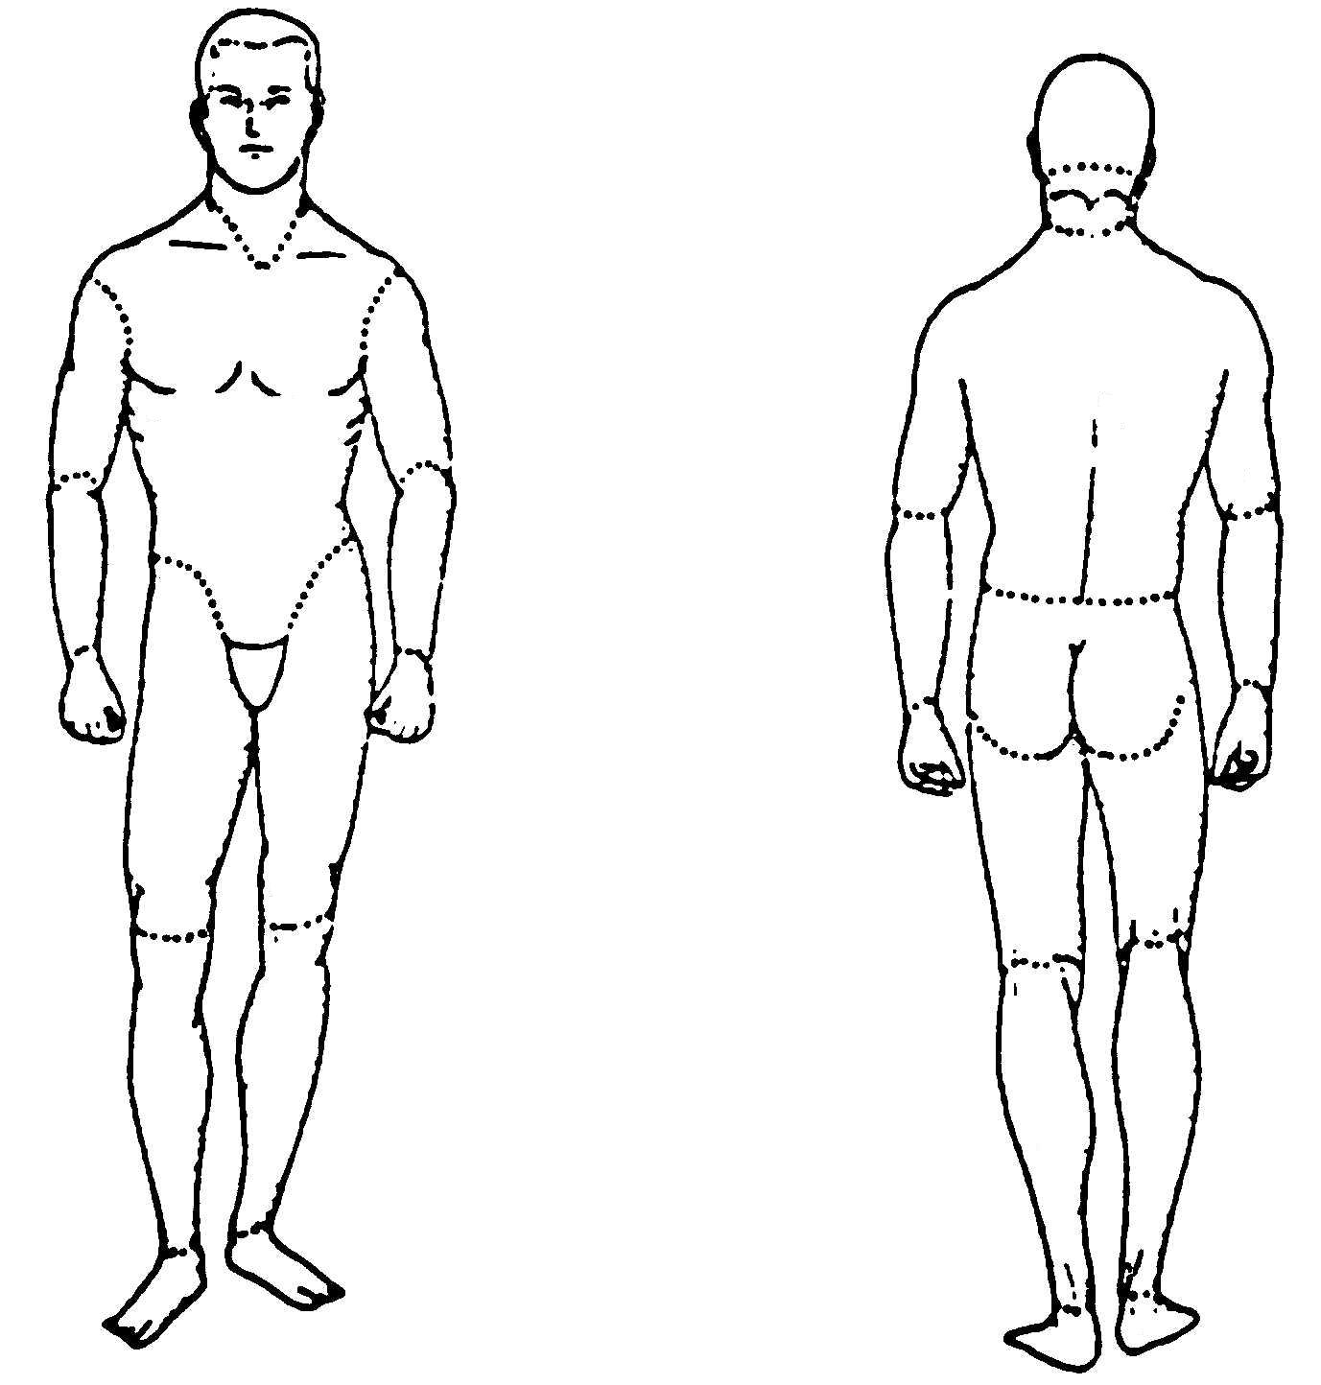
7. On diagram at right, shade areas where you feel _

pain and put an X on the areas that hurt the most.

 |  | None |  | Mild | Moderate |  |  | Severe |  | Comments
8. Tick the word that best describes how, during the
past 24 hours, pain has interfered with your:
General activity
Mood
Walking ability
Relations with others
Sleep
Enjoyment of life
Client’s Goals

Outcomes / recommendations for service plan

